LINUX COMMANDS EXECUTION
- Identifying directory and file
File – Initially it represents ‘-‘
Directory- Initially it represents ‘d’
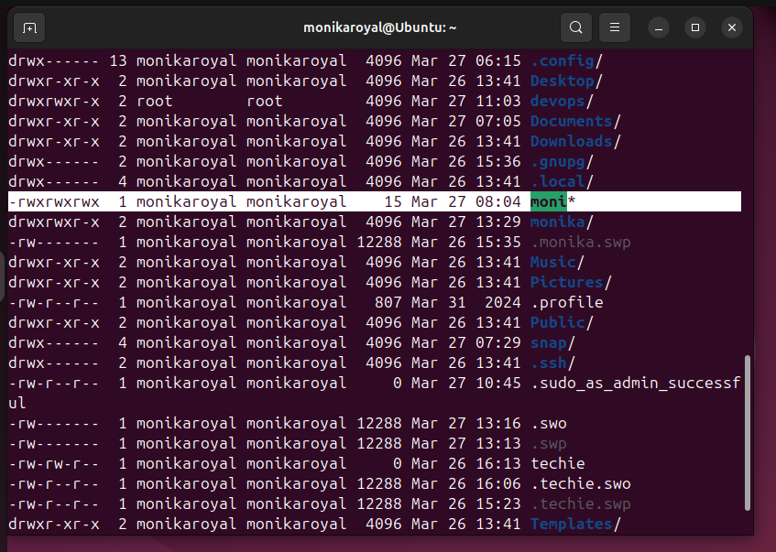

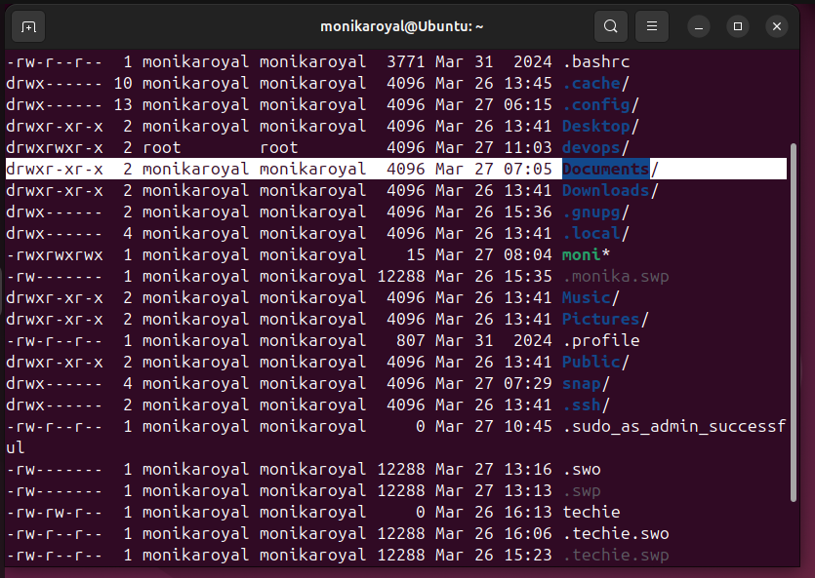

chmod 777 - To modify the access and permission

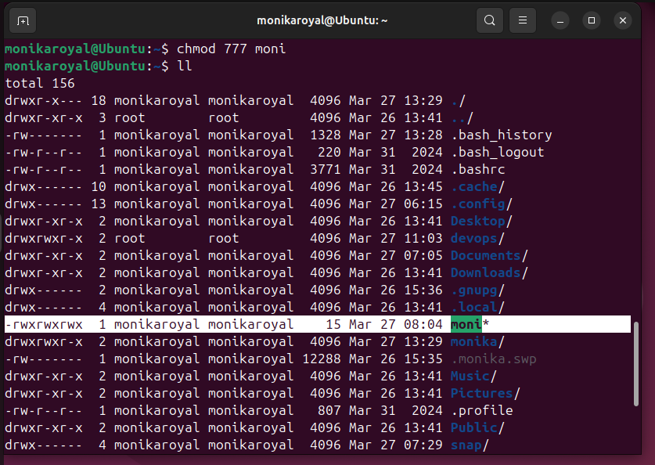

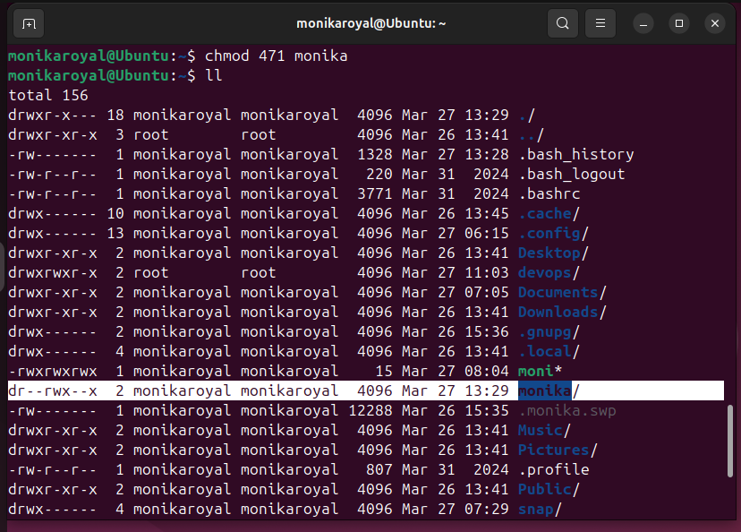
User should have read access, group should have read, write and execute access and others should have execute access. What should be the permissions ?
- chmod 471
cat /etc/passwd – To check the list of users in the virtual machine
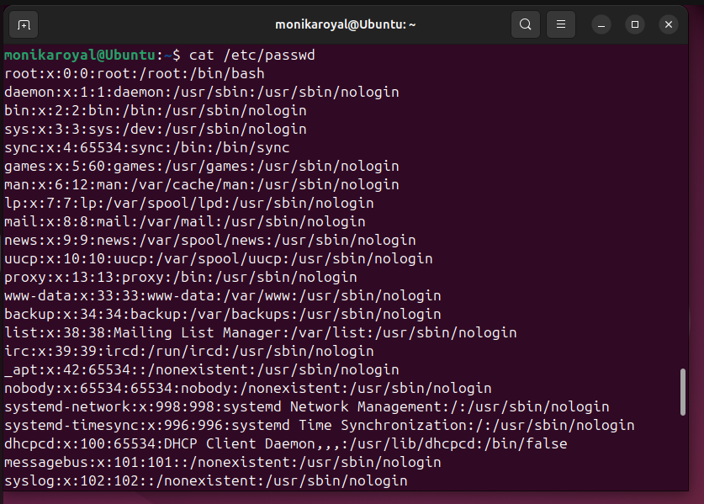

chown – change ownership
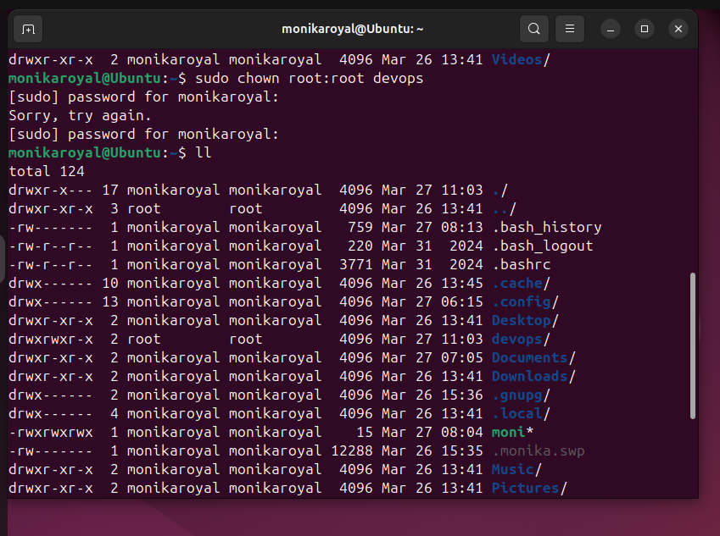

sudo su – Switch user

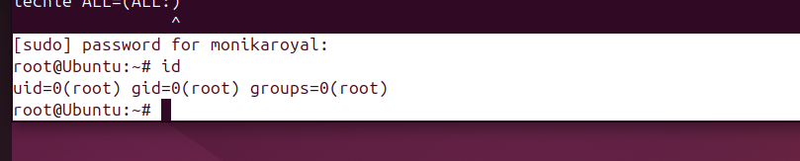


useradd – to create user
passwd- to create password
cat /etc/passwd – to check the user

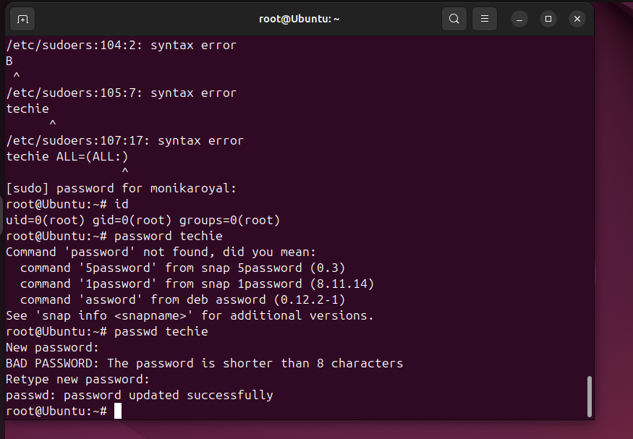
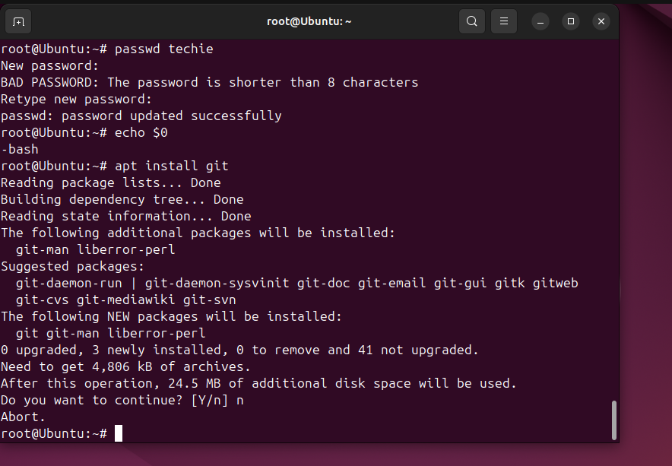

vi / etc/sudoers- where we can give permissions
